# Lab 04 Practice Test

1. **Draw a sketch of the Case**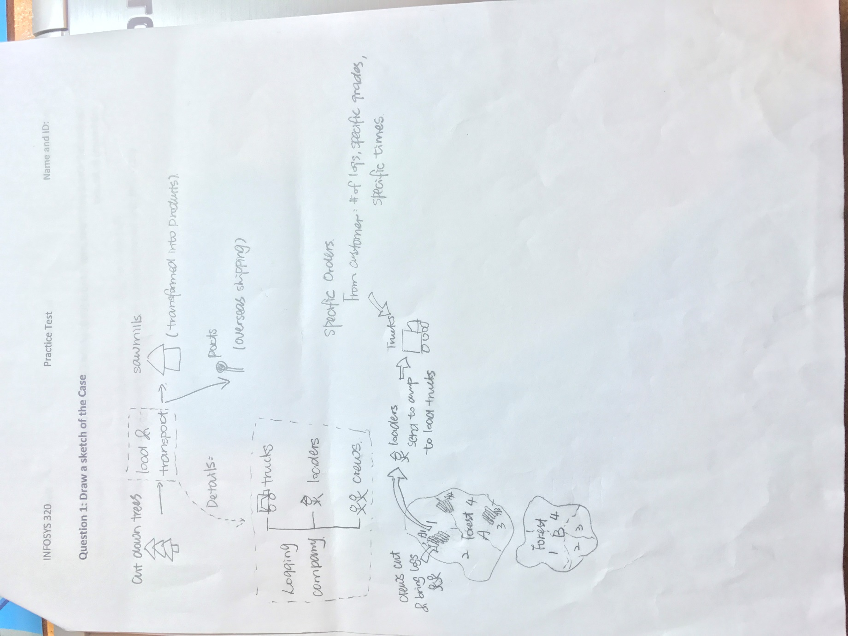
2. **ERD of the Case**

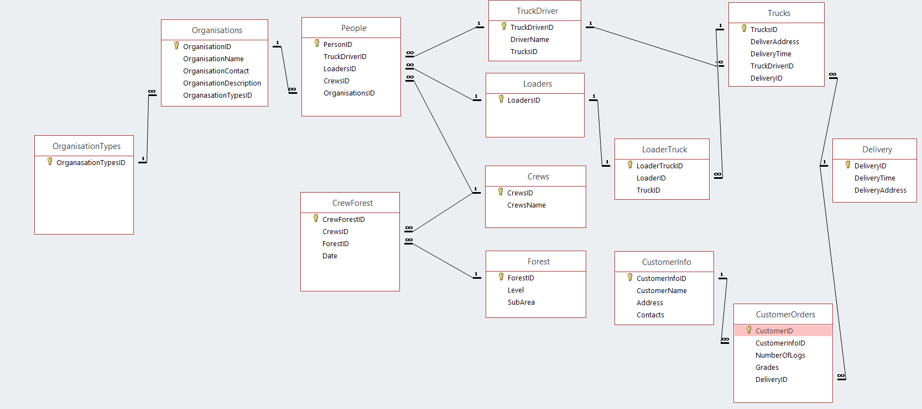

1. **HoloLens Design Guidance**
2. **Make All Cubes Blue**

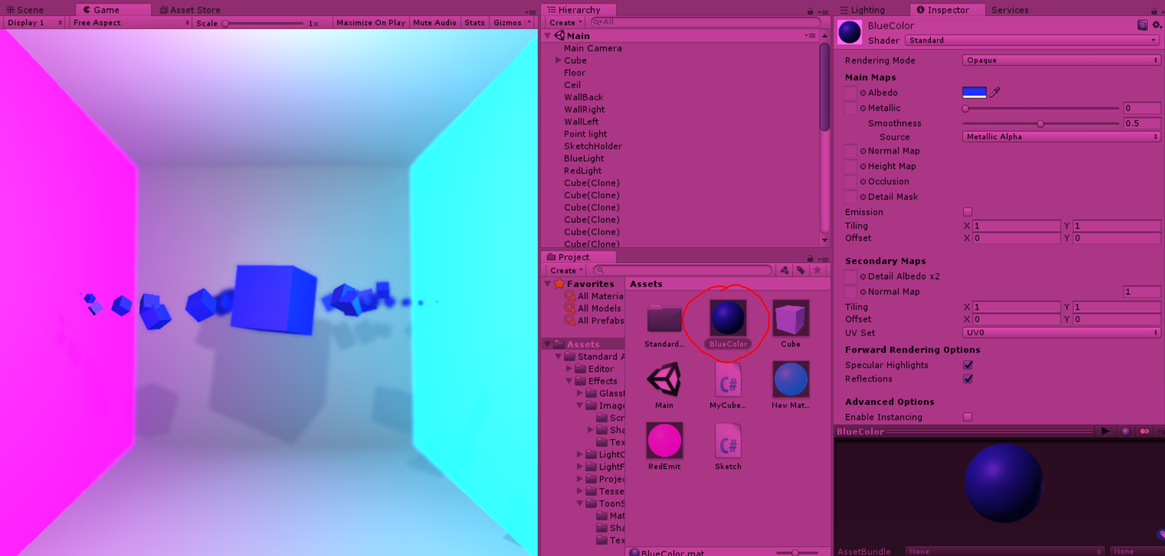

1. **Change the Color of One Cube Every Second in the Order They Were Created**
2. **Instead of rotating the cubes place randomly in the 3D space**

(I’m not sure about this, does this count?)

